CLIENT INFORMATION SHEET (CIS)

- BUSINESS INFORMATION
 | Business Name | : | JML FINANCIAL SERVICES & INVESTMENT MANAGEMENT CO., LTD.
 | Business Name in Vietnamese | : | CÔNG TY TNHH QUẢN LÝ ĐẦU TƯ & DỊCH VỤ TÀI CHÍNH JML
 | Registered Office Address and Mailing Address | : | No. 2, Street 13, Lakeview City,  Binh Trưng Ward,  Thu Duc - Ho Chi Minh City, Vietnam
 | Corporate license Number | : | 0315196684
 | Dated | : | 02/08/2018 (amended 25/09/2023)
 | Jurisdiction | : | Vietnam
 | Telephone | : | +84 90 666 4218
 | Legal Representative Name | : | GIANG, Tuyet My (Ms. My Tuyet Giang)  General Director
 | Citizenship / Nationality | : | VIETNAMESE
 | Passport Number | : | E00905016
 | Expire Date | : | 06.OCT.2033
 | Date of Birth | : | 19.SEP.1989

- BANK INFORMATION
 | Bank Name | : | SAIGON THUONG TIN COMMERCIAL JOINT STOCK BANK (SACOMBANK)
 | Bank Address | : | 266-268, NAM KY KHOI NGHIA STREET, DISTRICT 3, HO CHI MINH CITY, Viet Nam
 | Swift Code | : | SGTTVNVX
 | Account Name | : | JML FINANCIAL SERVICES & INVESTMENT MANAGEMENT CO., LTD.
 | USD Account Number | : | 0602 0058 8668

Identity Document for Ms. My T. GIANG is shown below.

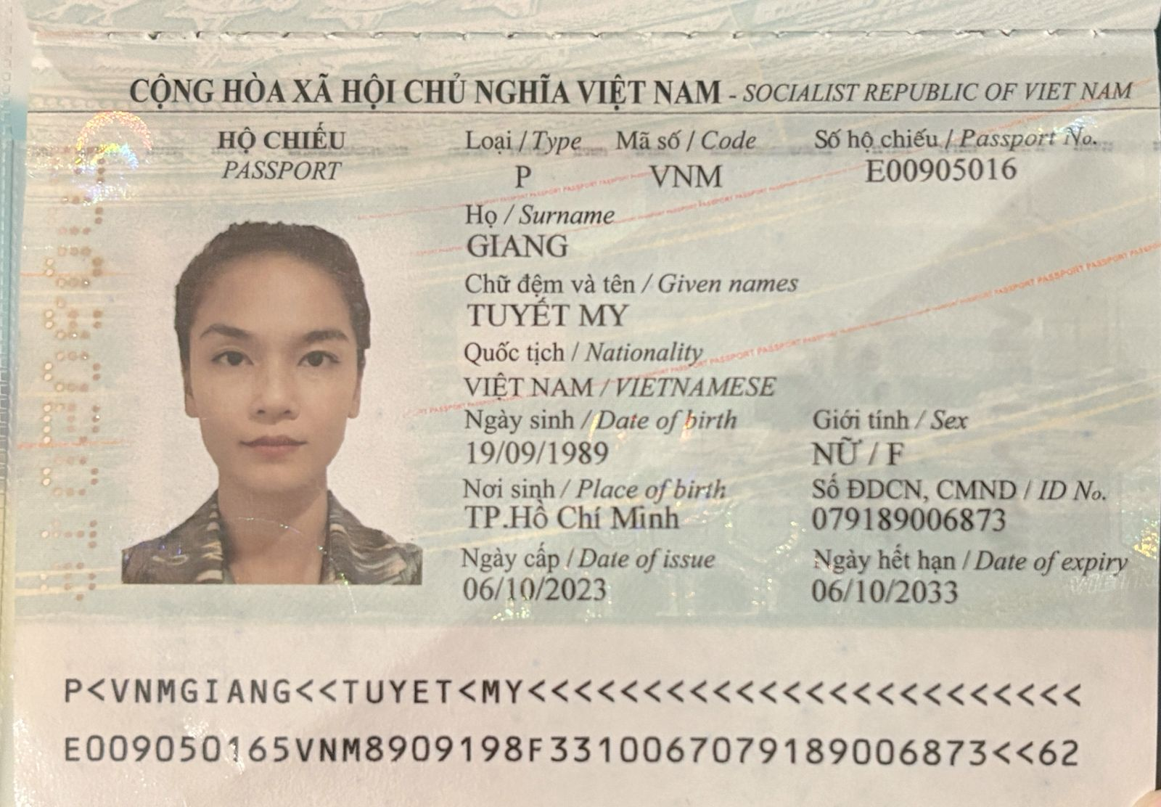

CORPORATE LICENCE
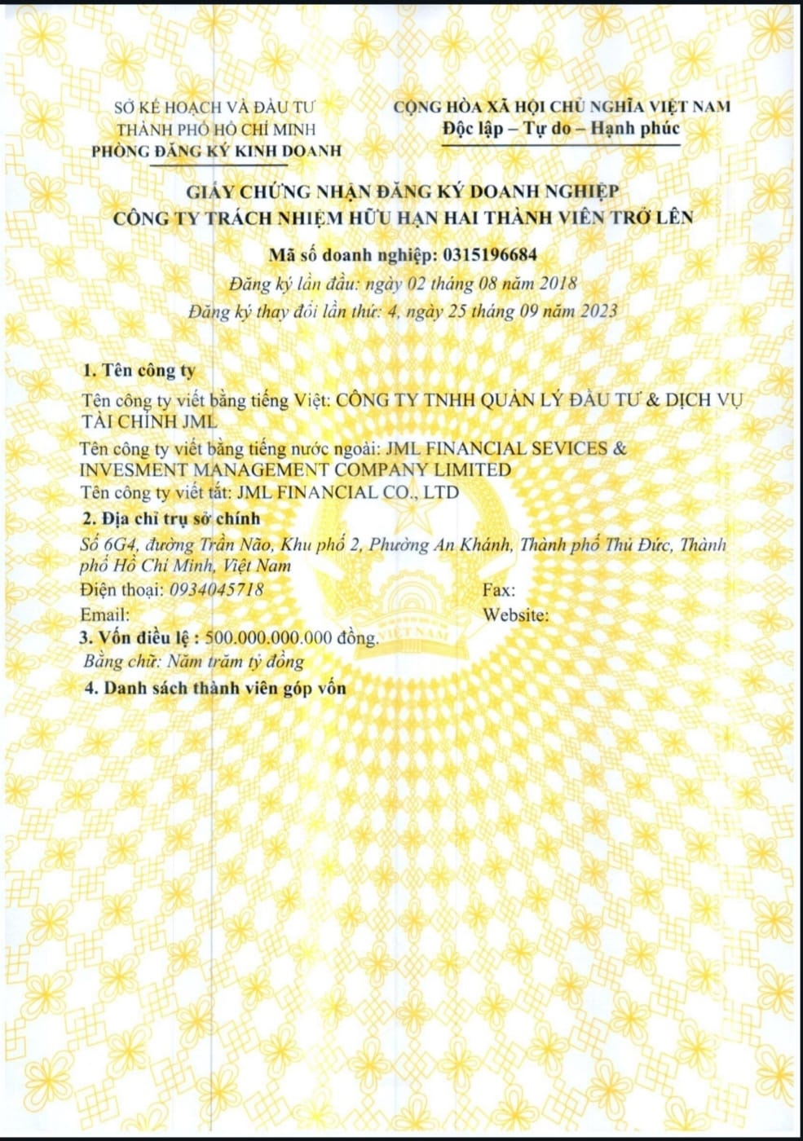

CLIENT INFORMATION (BANK ACCOUNT SIGNATORY/SIGNATORIES)
 | Client Name (Signatory 1) | : | JOHNNY DAVID LUU
 | Family Name | : | LUU
 | Given Names | : | Johnny David
 | Citizenship / Nationality | : | UNITED STATES OF AMERICA
 | Passport Number | : | A36808284
 | Issue Date | : | 04.OCT.2024
 | Expire Date | : | 03.OCT.2034
 | Issued by | : | UNITED STATES
 | National ID Number | :
 | Date of Birth | : | 02.JUL.1967
 | Place of Birth | : | VIETNAM
 | Client Name (Signatory 2) | : | GIANG Tuyet My
 | Family Name | : | GIANG
 | Given Names | : | Tuyet My
 | Citizenship / Nationality | : | VIETNAMESE
 | Passport Number | : | E00905016
 | Issue Date | : | 06.OCT.2023
 | Expire Date | : | 06.OCT.2033
 | Issued by | : | Vietnam
 | National ID Number | : | 079189006873
 | Date of Birth | : | 19.SEP.1989
 | Place of Birth | : | Ho Chi Minh City, Vietnam

SIGNATORY 1 PASSPORT / ID

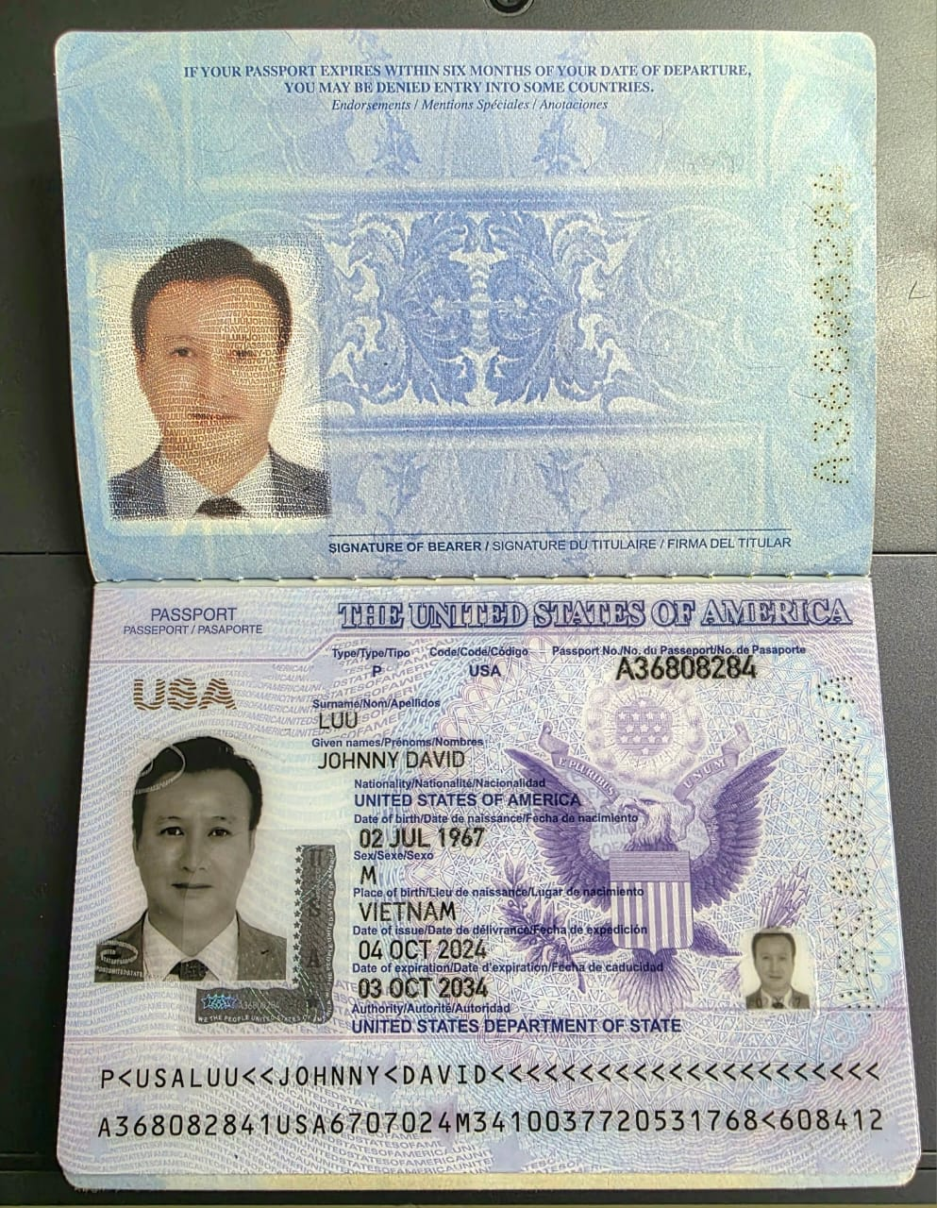

________________________________________
Name: Johnny David LUU
Passport No. : A36808284
Issued Country: USA
Issued Date: 04 OCT 2024
Expiry Date: 03 OCT 2034

SIGNATORY 2 PASSPORT / ID



________________________________________
Name: GIANG, Tuyet My
ID / Passport No. : E009050165
Issued Country: Vietnam
Issued Date: 06.OCT.2023
Expiry Date: 06.OCT.2033

Acknowledged as true and correct information by,

Signed: ____________________________

Name: _____________________________
Title: _____________________
Date: _____________________

